- Title:
FireTwin AI: Intelligent Digital Twin Platform for Real-Time Fire Extinguisher Monitoring and Predictive Maintenance

- Description
FireTwin AI is an AI-powered digital twin platform designed to monitor and manage fire extinguishers across a university campus in real time. The system integrates IoT sensor data, interactive digital maps, live dashboards, predictive maintenance analytics, and automated alerts to ensure every fire extinguisher remains operational and compliant. By creating a virtual representation of physical fire safety assets, FireTwin AI enables proactive maintenance, improves emergency preparedness, reduces manual inspections, and enhances overall campus safety through intelligent decision-making.

- Current Status

Implemented (Prototype Stage)
The following features have been successfully implemented:
- React web client for digital twin visualization and fire extinguisher monitoring
- FastAPI backend for data processing, API services, and secure communication
- Real-time monitoring using:
  - MQTT-based IoT communication
  - WebSocket live updates
  - Interactive dashboard visualization
- PostgreSQL database for secure storage of:
  - Users and roles
  - Buildings and fire extinguishers
  - IoT sensor readings
  - Maintenance logs and alerts
- AI prediction prototype:
  - Failure probability prediction
  - Remaining Useful Life (RUL) estimation
  - Risk score generation
- Digital Twin visualization with:
  - Interactive campus map (Leaflet.js)
  - Real-time extinguisher status
  - Live KPI dashboard
- Fire extinguisher management including:
  - CRUD operations
  - Search and filtering
  - Maintenance scheduling
- Dockerized deployment with:
  - React Frontend
  - FastAPI Backend
  - PostgreSQL Database
  - Eclipse Mosquitto MQTT Broker
- Secure authentication using JWT-based Role-Based Access Control (RBAC)
- Responsive user interface with analytics dashboards and report generation
- Project documentation including system architecture and API documentation
- Result
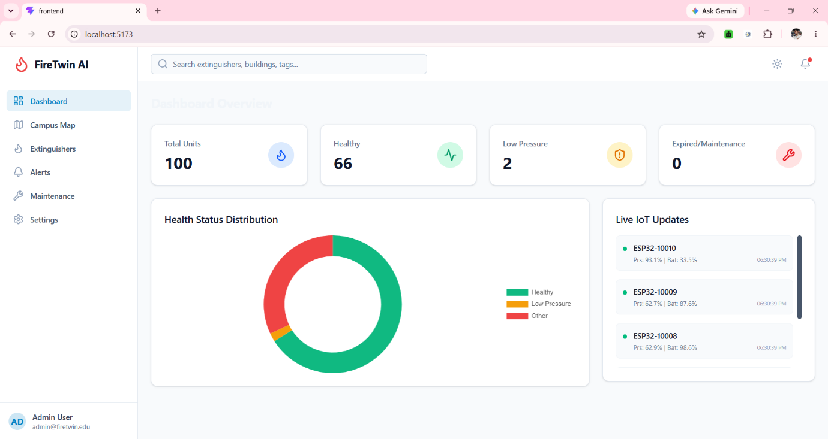
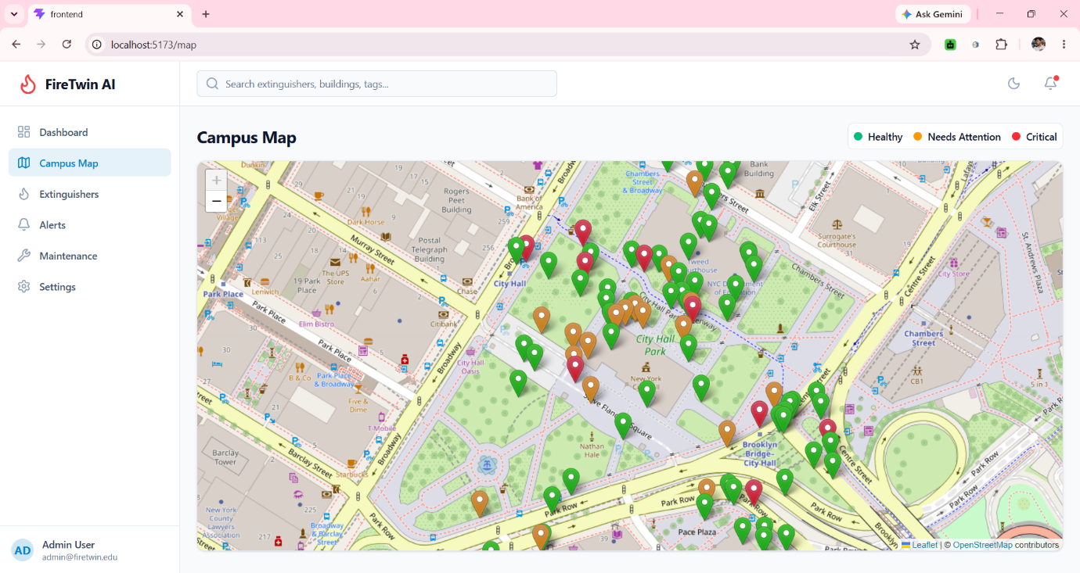
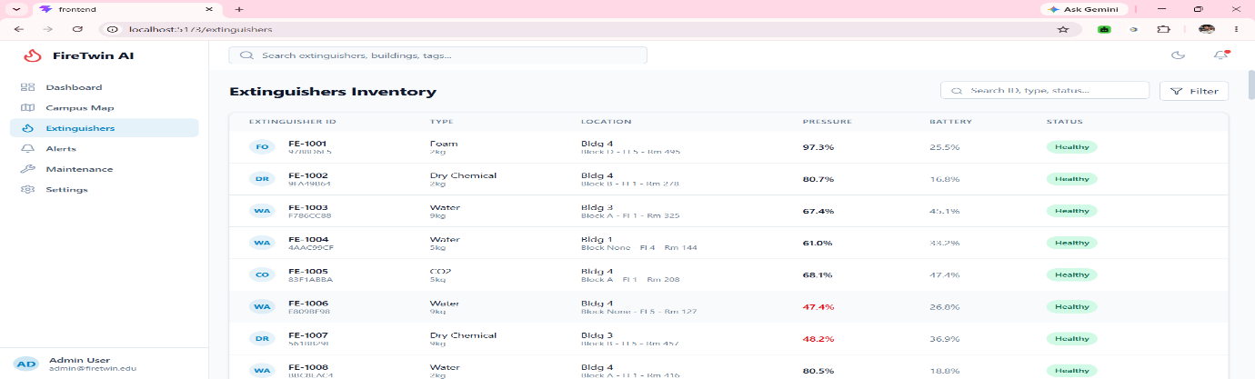

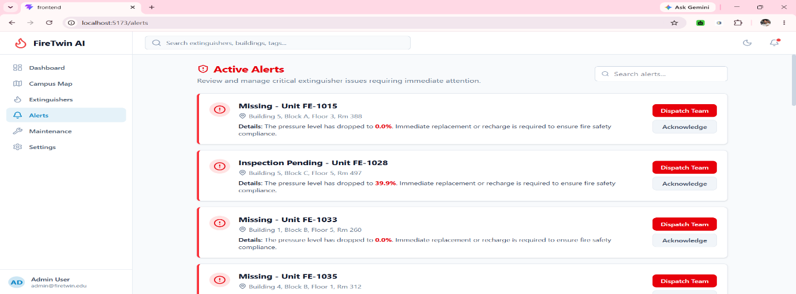

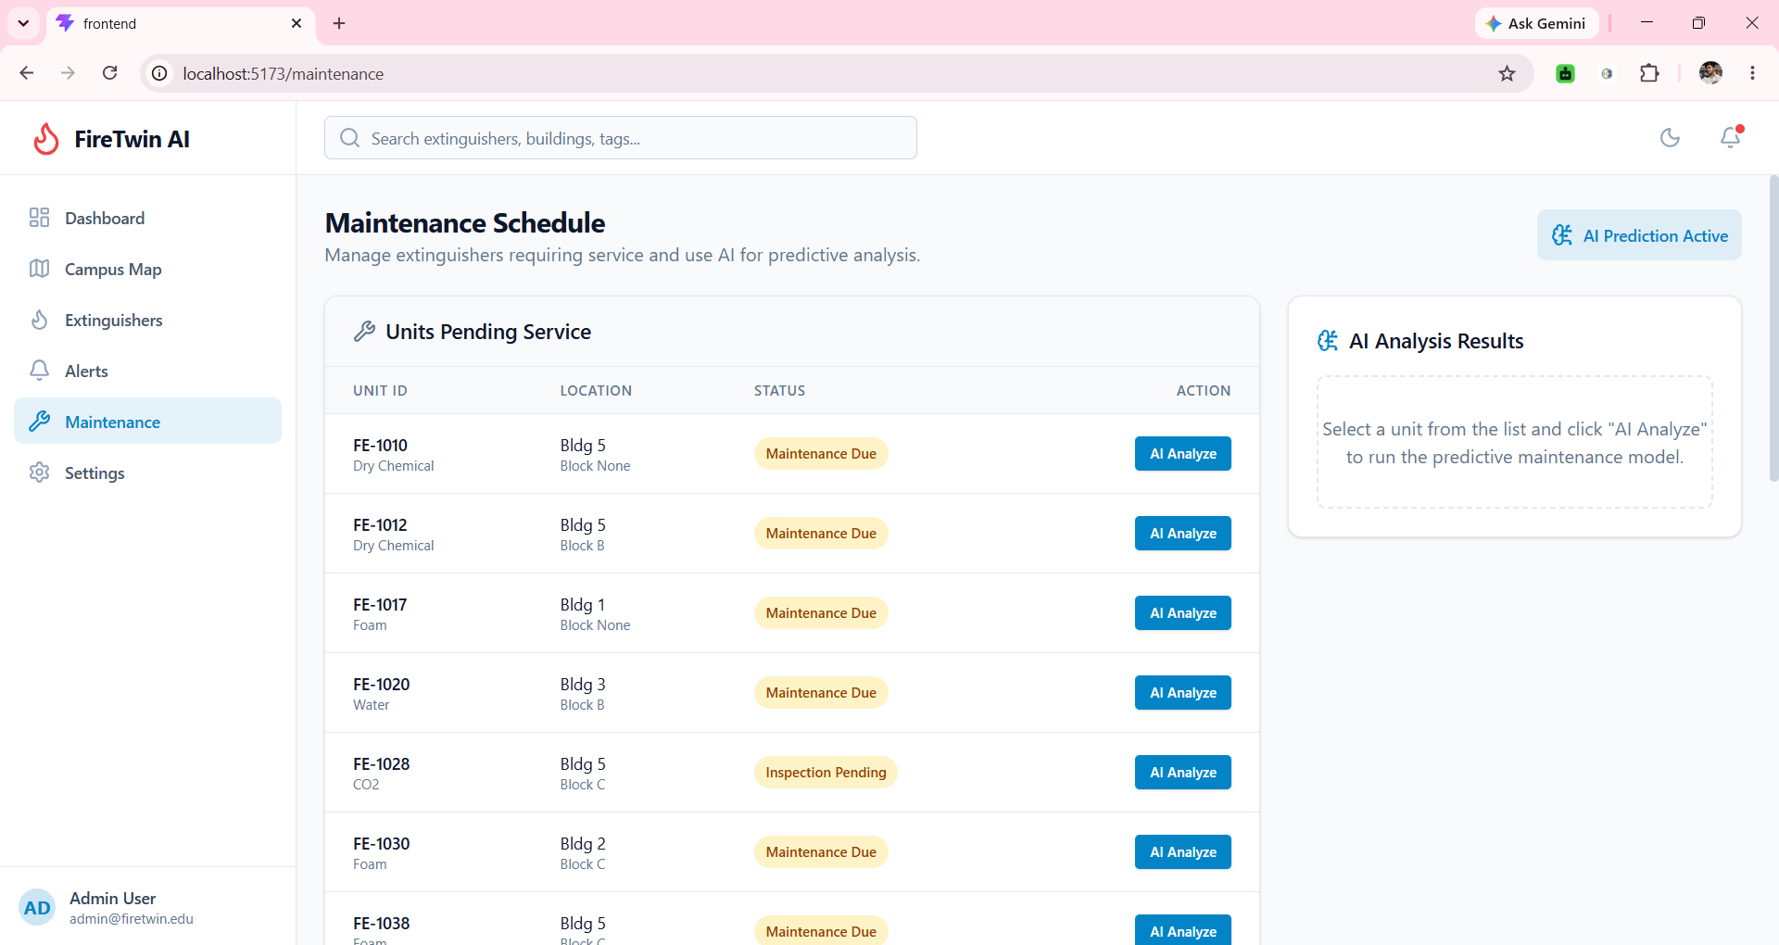
- System Architechture

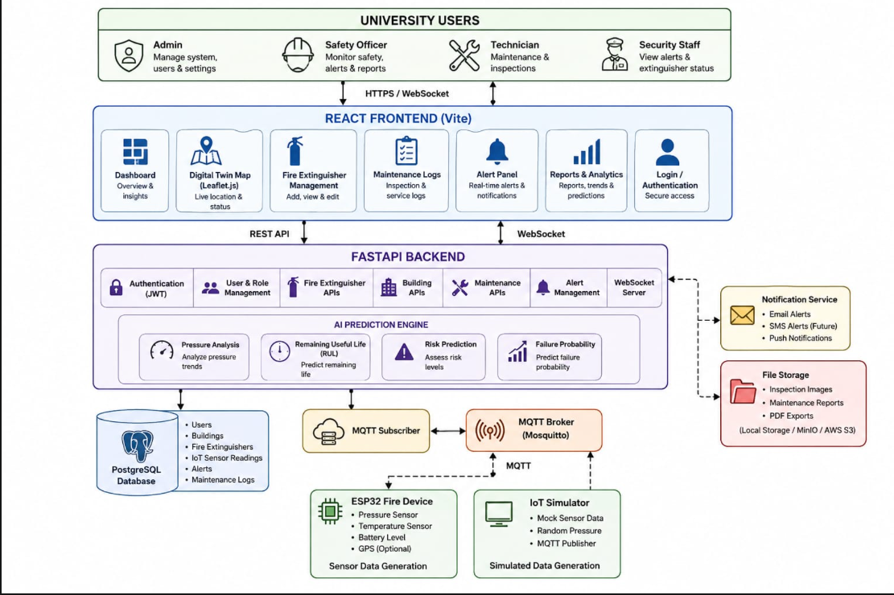

- Student Details

Student Name: Srinjoy Paul
Student Code: BWU/BTD/24/064
Phone Number: 9123385733

